What is cloud computing?
Cloud computing is the on-demand delivery of IT resources over the Internet with pay-as-you-go pricing. Instead of buying, owning, and maintaining physical data centers and servers, you can access technology services, such as computing power, storage, and databases, on an as-needed basis from a cloud provider like Amazon Web Services (AWS), IBM, Azure, GCP, Alibaba
Remotely access resources via internet.
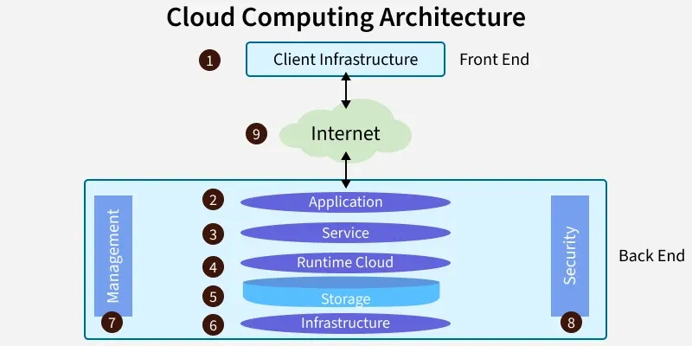
Why Cloud Computing
Cost efficiency
Scalability
Flexibility
Accessibility
Performance and reliability:
Disaster recovery and data backup
Automatic updates:
Enhanced security

Advantages of Cloud Computing
1. Cost Efficiency
- No need to buy expensive hardware or maintain data centers.
- Pay-as-you-go model reduces unnecessary spending.
2. Scalability & Flexibility
- Instantly scale resources up or down based on demand.
- Perfect for apps with unpredictable or seasonal workloads.
3. Accessibility from Anywhere
- Access data and applications from any device with an internet connection.
- Supports remote work and global teams.
4. Reliability & High Availability
- Built-in backups, disaster recovery, and redundancy.
- Cloud providers offer 99.9%+ uptime.
5. Automatic Updates
- System, security, and feature updates are handled automatically.
- Saves time and reduces maintenance work.
6. Strong Security
- Cloud providers invest in advanced security measures like:
  - encryption
  - identity management
  - threat detection
7. Faster Deployment
- You can launch servers or applications within minutes.
- Speeds up development and innovation.
8. Collaboration Made Easy
- Multiple users can work on the same data or project in real time.
9. Unlimited Storage
- Virtually limitless storage options that can grow with your needs.
10. Access to Advanced Technologies
- Easy integration with:
  - artificial intelligence (AI)
  - machine learning
  - big data analytics
  - IoT services
  - serverless computing
What is Private Cloud ?
What is Public Cloud ?
What is Hybrid Cloud?

IaaS (Infrastructure as a Service)
Provides the fundamental building blocks for cloud IT: access to networking features, computers (virtual or dedicated), and data storage space.
PaaS (Platform as a Service)
Provides a platform for developers to build, run, and manage applications without the complexity of building and maintaining the infrastructure typically associated with it.
SaaS (Software as a Service)
It means using software on the internet without installing it on your computer.
You just open it in a browser and start using it. The company manages everything like servers, updates, and security.
